

Come & Enjoy Burger Love!
Stay with us & receive 15% discount when requesting
Burger Love Promotion!
Use promo code PROMO15

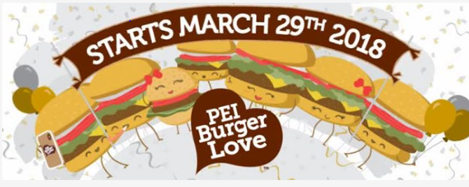
PEI Burger Love 2018 - 29th March – April 30th

Check out their link: https://peiburgerlove.ca/
*Must be requested at time booking. May not be combined with other
discounts or offers. Subject to availability *

CHARLOTTETOWN, PRINCE EDWARD ISLAND • PHONE 902.892.2461 OR 1 855.937.8734
reservations@charlottetowninn.com

